

import java.util.Scanner:

class prog{

public static void main(String[] args)( Scanner input = new Scanner(System.in); int a = input.ncxtInt();

if(a%2==0){

System.out.println(1);

elsc(

System.out.println(2);

Input Expected Got

V 123 2 2

456 1 1

Passed all tests!

REC—CIS

Falling back to raw text area

java.util.Scanner:

class

'c void m’'n Scanner

nncn’ yst g.!n):

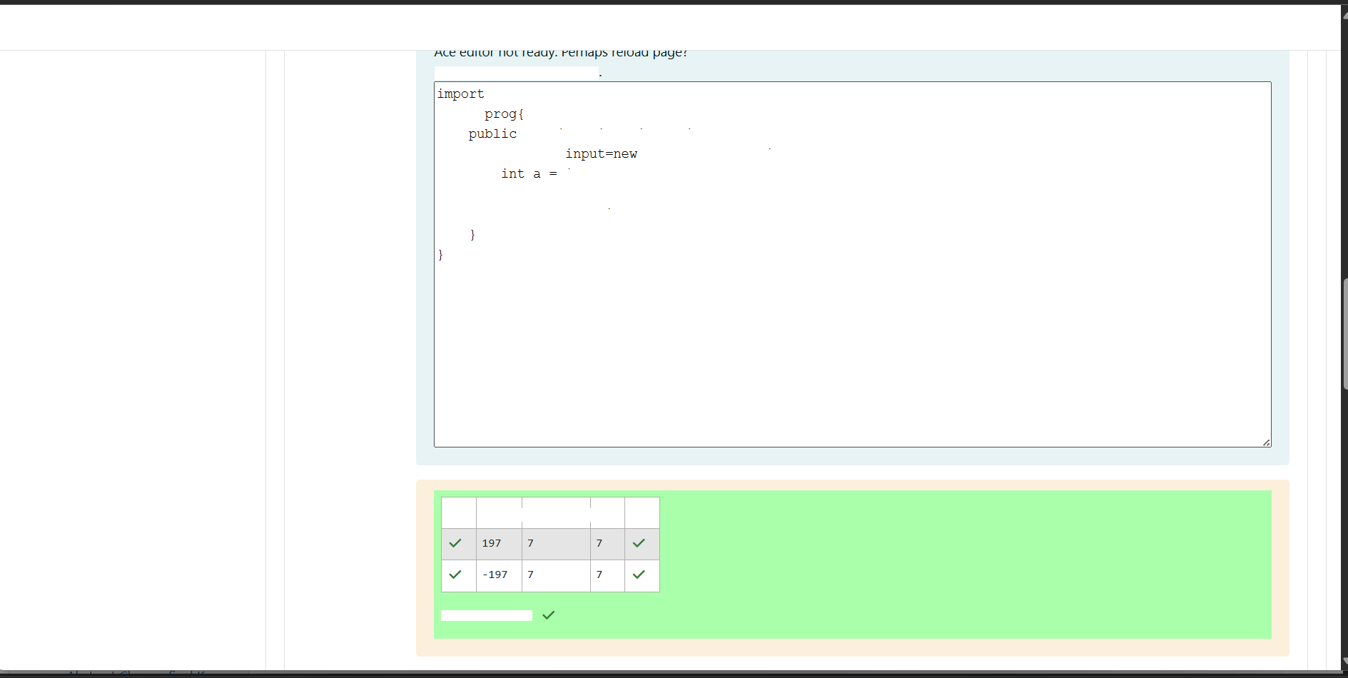input.ncxtInt(); a=(a>= ?a:(-l\*a);

System.out.printf("{d",a%l0):

Input Expected Got

Passed all tests!

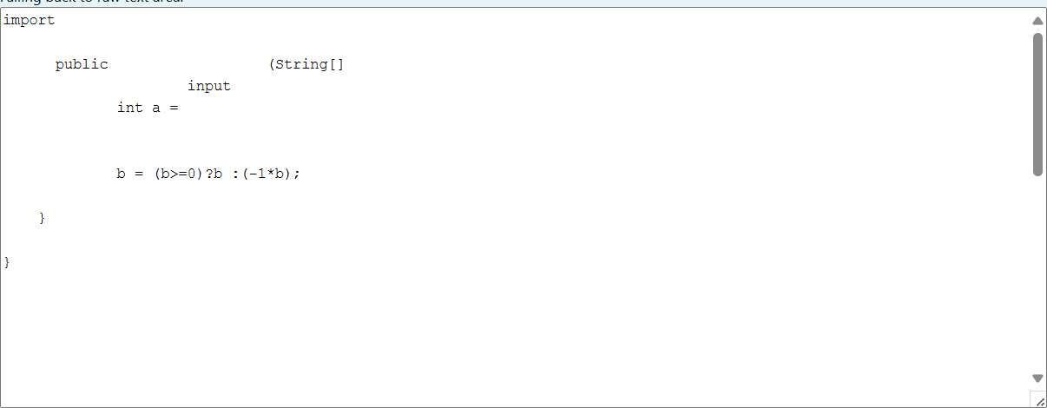

java.u-il.Scanner;

klass proq{

static vcid main

args){

Scar.r.ar = new Scanner(Sys-em.ir.); input.nextIr.t();

int b=input.r.ax-Int();

a = (a>=J)7a: (-lra);

Syster.c.t rin-("°d", %10)+(b°lC);

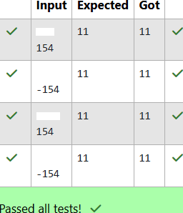

267

267

*- 267*

*- 267*